Infosys Springboard Virtual Internship 6.0 Completion Report

Team Details
Batch Number 13 Start date: 03/02/2026
Name: Onkar Vyawahare
Internship Duration: 8 Weeks

- Project Title
Interactive Analytics Dashboard and Web Portal for Global Income Distribution.

- Project Objective

The main objective of my internship project was to analyze global income inequality and present it in a meaningful, interactive, and visually engaging way.

I aimed to transform raw socioeconomic data into actionable insights using data analytics and full- stack development. The project focuses on helping users understand income distribution patterns, inequality severity, and inclusive development across countries.

Additionally, the goal was to build a complete end-to-end solution, including:

  - Data collection and preprocessing
  - Analytical dashboard development
  - Full-stack web application deployment
  - User interaction and admin monitoring system.

- Project description in detail

The project focuses on analyzing and visualizing global income inequality using an integrated data analytics and web-based approach. It is designed to help users understand how income is distributed across different countries and how economic growth relates to social equality.

At its core, the project provides an interactive analytical dashboard that presents key indicators such as income inequality levels, economic performance, and inclusive development. The dashboard enables users to explore trends, compare countries, and identify patterns in income distribution through dynamic visualizations.

To enhance accessibility and usability, the project was extended into a full-stack web application. This platform serves as a centralized system where users can not only view the dashboard but also interact with it in a seamless and user-friendly environment.

A key highlight of the system is the Admin Portal, which provides administrative control over the platform. It allows monitoring of user activity, management of user accounts, and handling of queries submitted through the system. This adds a layer of scalability and real-world applicability to the project.

From a technological perspective, the project integrates data analytics tools with modern web development frameworks, creating a complete end-to-end solution. It demonstrates how raw data can be transformed into meaningful insights and delivered through an interactive digital platform.

In real-world scenarios, this project can be useful for researchers, students, and policymakers who want to study economic inequality and make data-driven decisions. It simplifies complex datasets into intuitive visuals, making analysis more accessible and impactful.

- Timeline Overview
Week | Activities Planned | Activities Completed
Week 1 | Data collection | 06.02.2026
Week 2 | Data cleaning | 13.02.2026
Week 3 | Data transformation, Power BI setup | 20.02.2026
Week 4 | Measures creation, Dashboard development | 27.02.2026
Week 5 | Web Exploration | 06.03.2026
Week 6 | Web development | 13.03.2026
Week 7 | Web Enhancements | 20.03.2026
Week 8 | Final execution | Yet to be Done

5a. Key Milestones
Milestone | Description | Date Achieved
Project Kickoff | Data collection started | 03 Feb 2026
Prototype/First Draft | Initial dashboard created | 20 Feb 2026
Mid-Term Review | Dashboard finalization and enhancements | 27 Feb 2026
Final Submission | Web portal completed | 20 Mar 2026
Presentation | PPT and demo completion | 26 Mar 2026

5b. Project execution details

This project was developed in multiple structured phases:

Milestone 1 – Data Collection & Preparation

In the first phase, I collected datasets related to global income inequality from the World Bank database. The key indicators included:

  - Gini Index
  - Income share held
  - GDP per capita
  - Unemployment Rate

I performed data cleaning such as:

  - Removing unnecessary columns
  - Standardizing column names
  - Handling missing values using interpolation and averaging
  - Converting data formats

Finally, I converted all datasets into long format and merged them into a single master dataset.

Milestone 2 – Data Transformation & Dashboard Development

In this phase, I used Power BI to build an analytical dashboard. I created advanced calculated measures such as:
  - GDP YoY Growth %
  - Gini Change YoY
  - Unemployment YoY Change
  - Polarization Index

I also created classification columns to categorize countries based on inequality levels and economic performance.

The dashboard includes:

  - KPI summary cards
  - Global Overview
  - Trend analysis charts
  - Comparative analysis sections

This allows users to explore data interactively and gain meaningful insights.

Milestone 3 – Web Portal Development

In this phase, I developed a full-stack web application to host the dashboard. The platform includes:
  - Public pages explaining global inequality
  - User login and authentication system
  - Embedded Power BI dashboard
  - Country comparison tools
  - Data download features

An Admin Portal was also developed with:

  - User management system
  - Session tracking
  - Query management
  - Analytics monitoring Technologies used:
  - Frontend: HTML5, CSS3, JavaScript
  - Backend: Flask (Python 3.x)
  - Database: SQLite, SQL Alchemy
  - Authentication: Flask-Login

Milestone 4 – Final Execution & Presentation

In this phase, our instructor divided us into two groups:

  - PPT Presentation Team
  - Demo Team

Both groups worked simultaneously on:

  - Individual documentation preparation
  - Group documentation
  - PPT creation
  - Website enhancements

During this phase, I contributed to:

  - Refining the website features
  - Preparing documentation
  - Supporting presentation and demo readiness

This phase helped in improving both technical and communication skills.

- Snapshots / Screenshots

Dataset After Cleaning and Merging

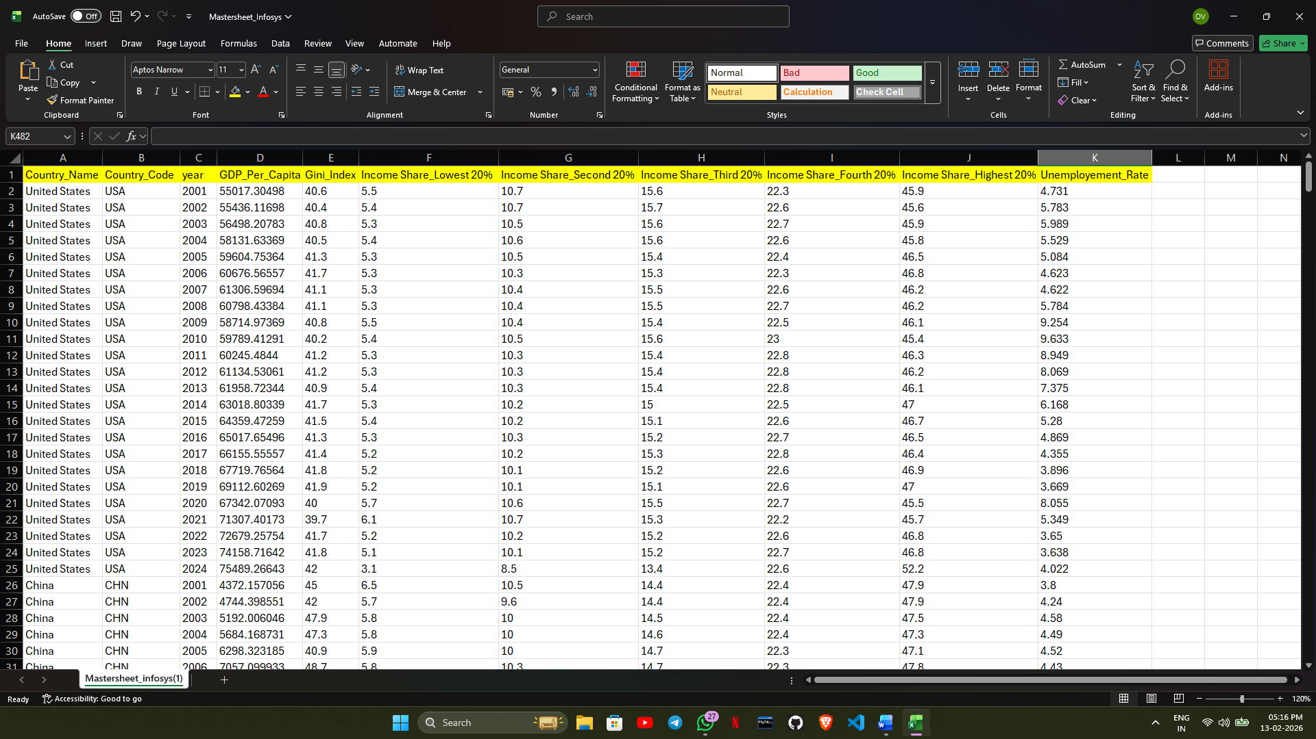

After Calculated Columns and Measures creation

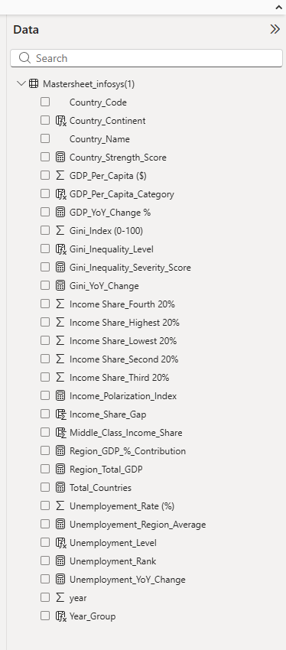

Dashboard Overview

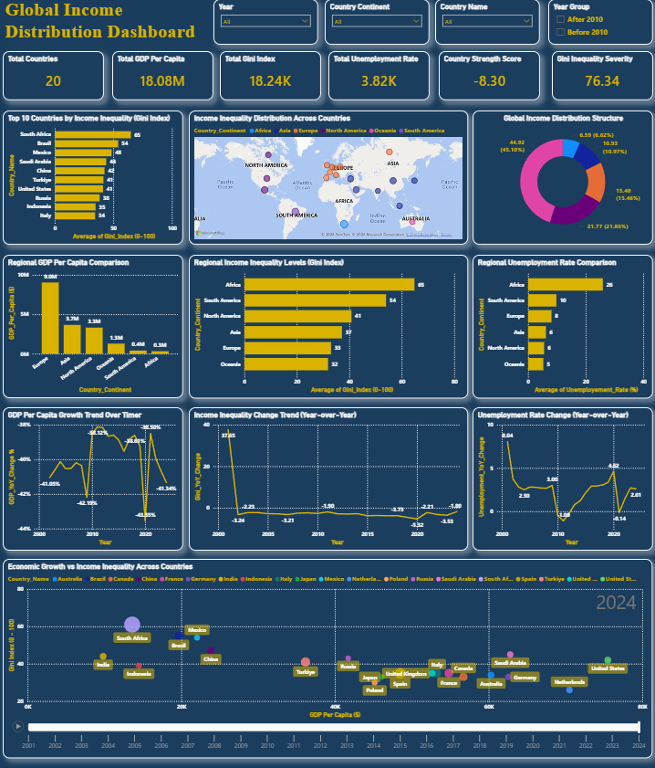

Authentication System

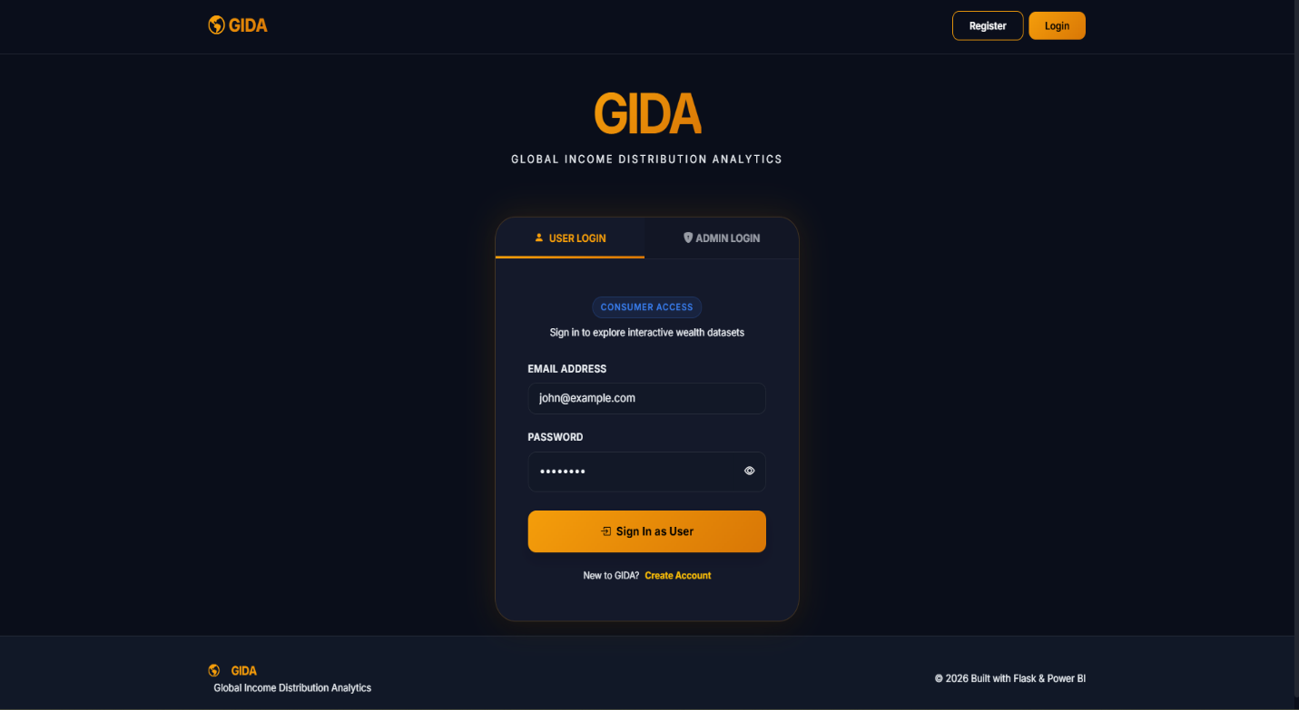

Home Page

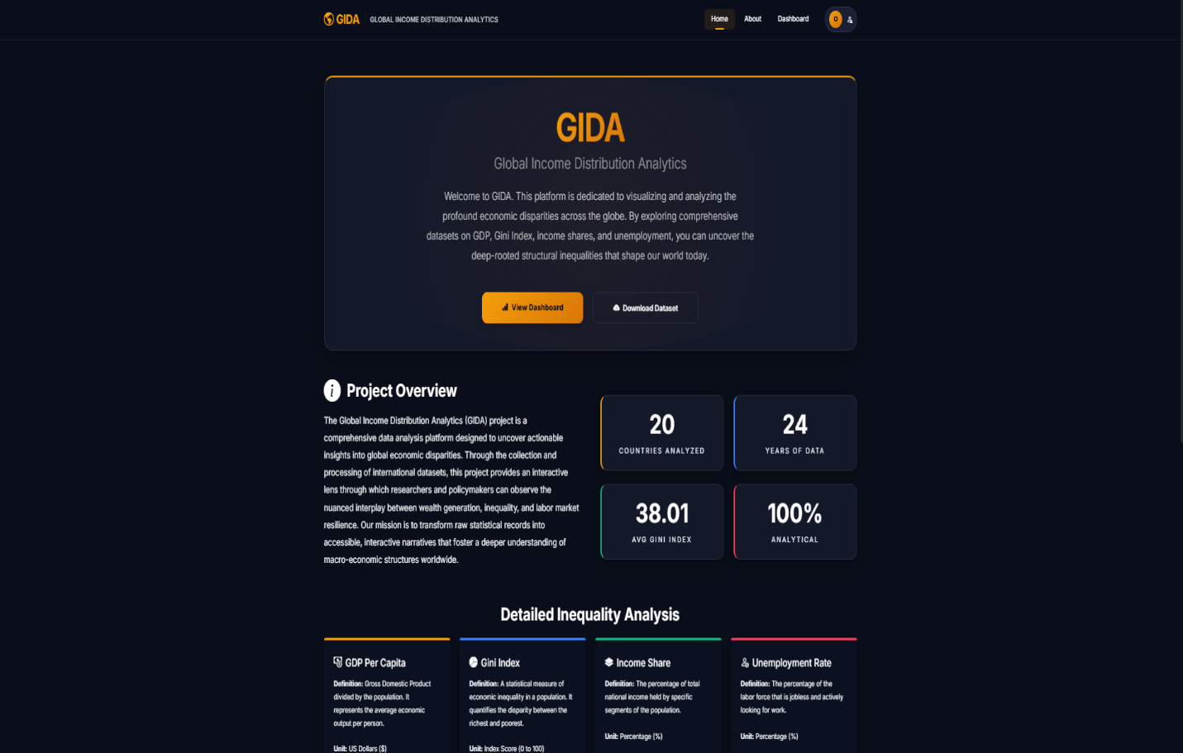

Admin Portal

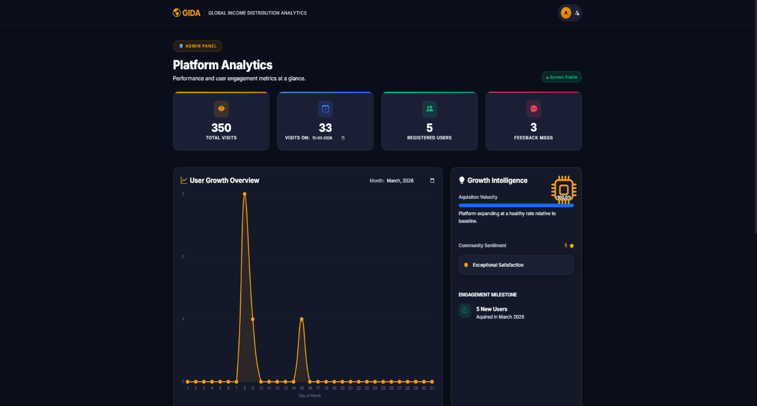

Deployed Website

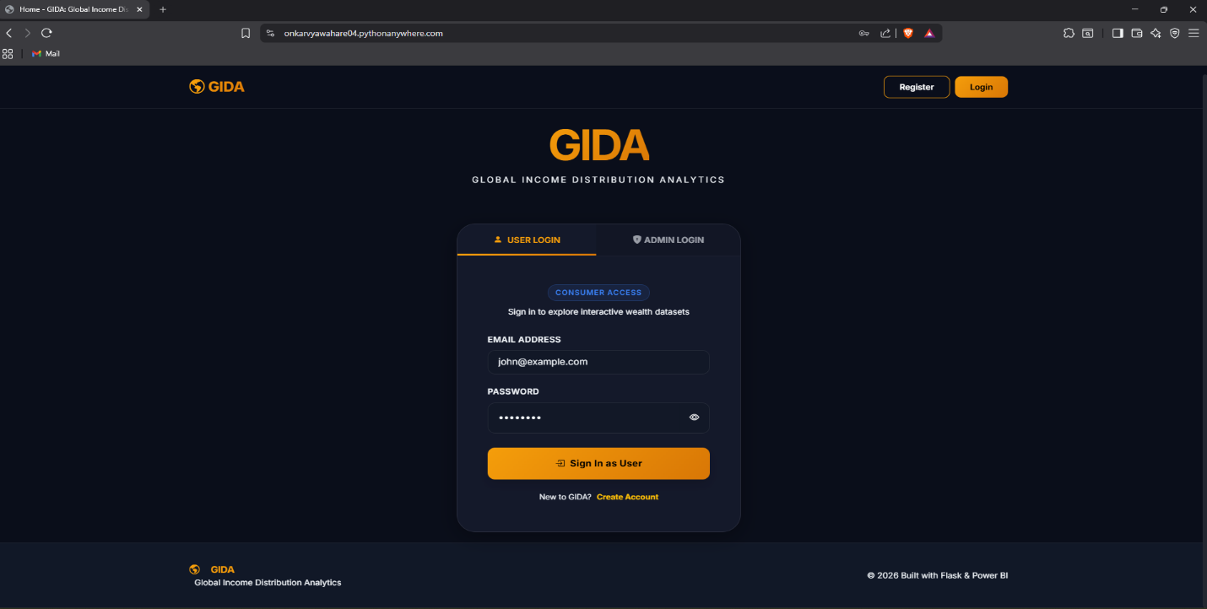

- Challenges Faced

Some challenges I faced during the project were:

  - Handling missing and inconsistent data
  - Creating Insightful KPI Cards
  - Integrating Power BI with web application
  - Implementing secure authentication
  - Managing backend and frontend communication I resolved these by:
  - Applying proper data cleaning techniques
  - Learning DAX functions
  - Debugging integration issues
  - Testing authentication flows.

- Learnings & Skills Acquired Technical Skills
  - Data Cleaning and Transformation
  - Power BI Dashboard Development
  - DAX Calculations
  - Full-stack Development
  - Database Design (SQLite)
Soft Skills

  - Problem-solving
  - Team collaboration
  - Documentation
  - Presentation skills.

- Testimonials from team

This internship gave me hands-on experience in solving real-world problems. I was able to apply my knowledge in data analytics and development effectively.

It helped me improve my confidence in building complete projects and presenting them.

- Conclusion

This internship was a valuable learning experience.

I successfully built a complete system that analyzes global income inequality using both data analytics and web development.

It strengthened my technical skills and aligned with my career goal of becoming a developer.

- Acknowledgements

I would like to thank Infosys Springboard for providing this opportunity. I am grateful to my instructor and mentor for their guidance
I also thank my teammates for their support and collaboration throughout the project.

---- With this the Internship is Completed Successfully ----

